|  |  |
| --- | --- |
| Project Type | Internship |
| College Name | CDI College |
| Student Name | Barsha Shaikh |
| Student ID | 635-201244 |
| Duration | 8 Weeks |
| Completed | April 28th 2022 |

**Project Report**

**Oshawa Ecampus**

Contents

***1.*** ***Introduction 3***

**1.1** **Purpose 3**

**1.2** **Scope 4**

***2.*** ***General Description 5***

**2.1** **Product Functions 5**

**2.2** **User Characteristics 5**

**2.3** **User Characteristics 5**

***3.*** ***Specific Requirements 6***

**3.1** **Functional Requirements 6**

**3.2** **Non-functional Requirements 8**

***4.*** ***Analysis Models 9***

**4.1** **Use Case 9**

**4.2** **Sequence Diagrams 10**

**4.3** **Class Diagram 15**

**4.4** **Screen flows diagram and Screen design 16**

***5.*** ***Database 19***

**5.1** **Conceptual E-R Diagram 19**

**5.2** **Logical E-R Diagram 19**

**5.3** **Database Queries Screenshots 20**

***6.*** ***Use Case Scenarios 21***

**6.1** **User Story 21**

**6.2** **Use Case Scenario 23**

***7.*** ***Test Cases 30***

***8.*** ***References 40***

1. Introduction

The “Oshawa ECampus” website is a new and amazing online platform for Teachers and student to access their dashboard. This website will let the faculty and students to log in and have their own data stored. Teacher can create their login by adding their first and last name and password followed by the ID provided by the university.

It is built by using the following technologies:

Front End – HTML, CSS, PHP

Backend - JAVA and Firebase Database

Development Tool – Visual Studio 2010

* 1. **Purpose**

In this website the administrative functions are fulfilled through the online campus as well. Students can often view what courses are on. Admissions, technical assistance, and other services may also be located on this website.

* 1. **Scope**

This system can be used as an information management system for the campus. In this system the student and teacher can login and see their profiles.

1. General Description
   1. **Product Functions**
2. Add Student/teacher
3. Delete Student/teacher
4. View student
5. Grade update
6. Login
7. Log Out
   1. **User Characteristics (Students and Teachers)**
8. A use of the online ecampus website can be possible by the registered user only.
9. User can login.
10. User can view their profile.
11. User can add student, view student courses, view and update grade.
12. Easy to use interface.
13. User can add title, description to their account
    1. **User Characteristics**
14. User(Teacher) can disable/enable user from the database by adding or deleting.
15. User(Teacher) can send password reset for students.
16. Analysis Models
    1. **Use Case**

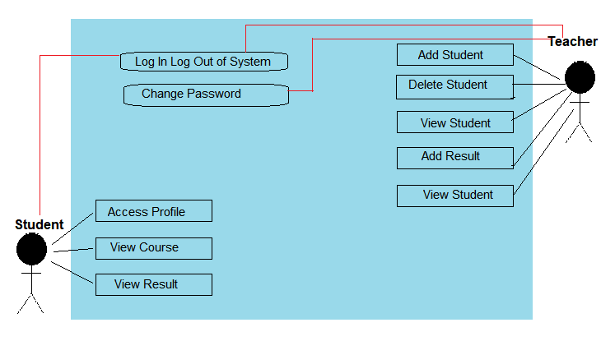

* 1. **Sequence Diagrams**

**USER Login (Teacher and Student)**

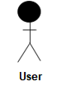

Check Authenticity

Authenticate Page

Database

Login Page

Forgot Password

Verification

Forgot Password

Login to Page

Check Login details

Valid Login Details

Provide Authorization for access

Create session in and store in Database

Check security

Question and Answer

Allow user to access the page

Send email to user to reset Password

Invalid Login Details

Logout from application

Login Successfully

Omit sessions and tokens from database

Allow user to access the page

Teacher Login Access:



Exam Management

Student Management

Course Management

Login Success

Teacher

Add/Edit Student

Add Exam

Save/update Course

List/Delete Course

Add/Edit Course

Manage Student

Login to Page

View Exam

Save/Update Student

Update Grades

List/Delete Student

Manage Course Detail

Manage Exam Detail

Student Login Access:



Exam Management

Student Management

Course Management

Login Success

Student

View Profile

Access Profile

Login to Page

View Exam

View Course

View Course Detail

View Exam Detail

Class Diagram:

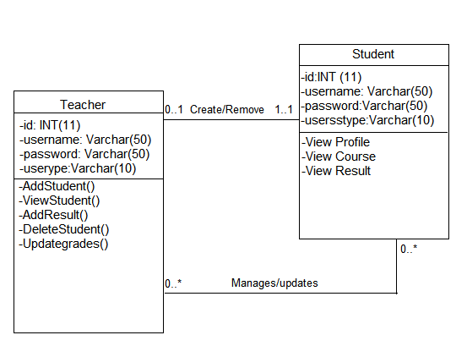

Screenshots:

Introduction of the Home Page of the Project:

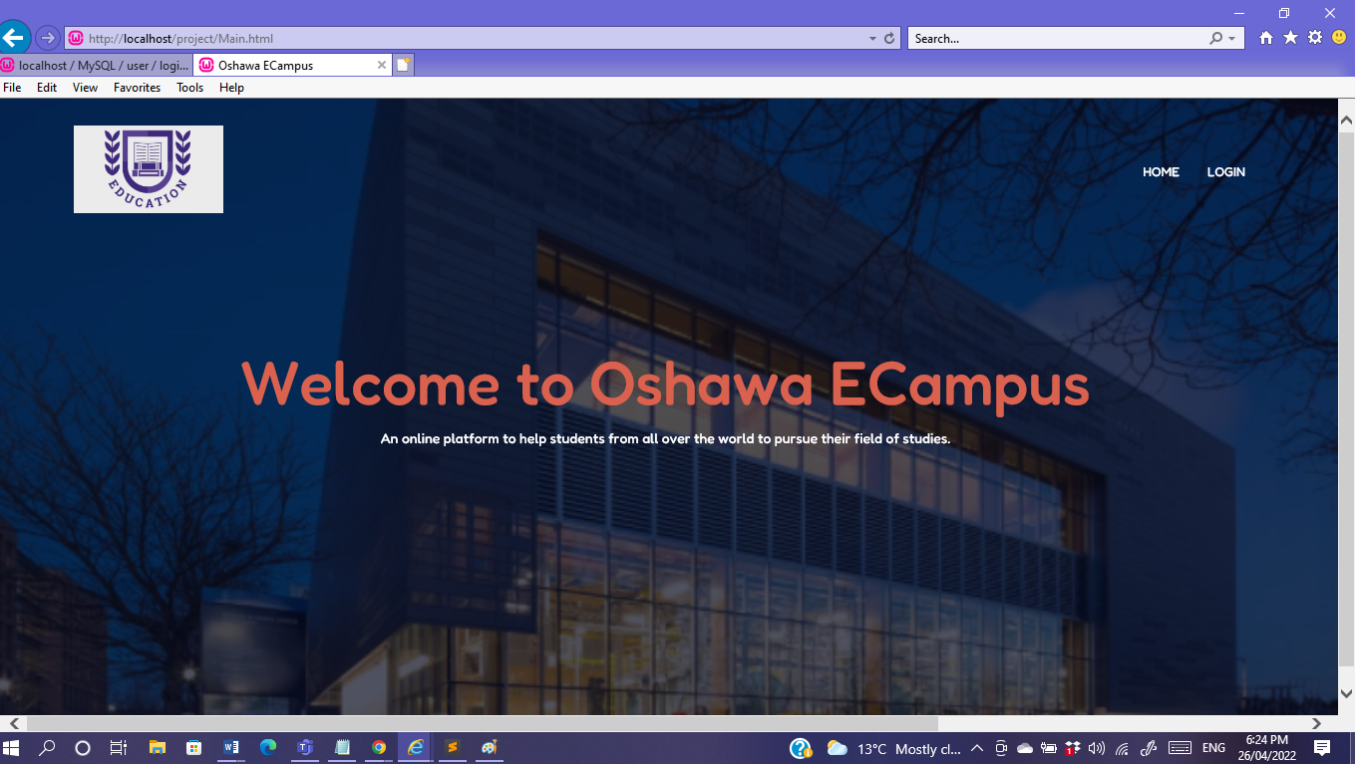

Login Form Page:

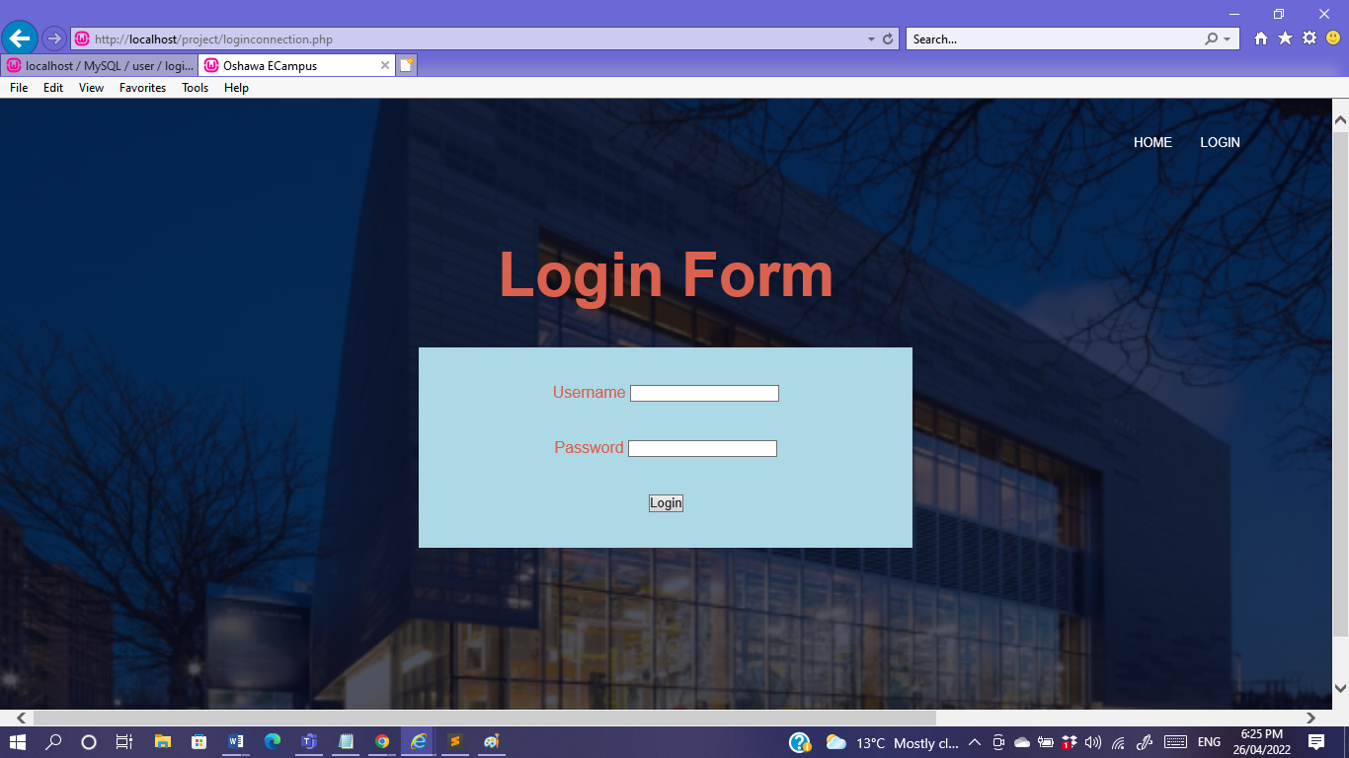

The Database used is in the Name of “user” under the Database 6 tables were used:

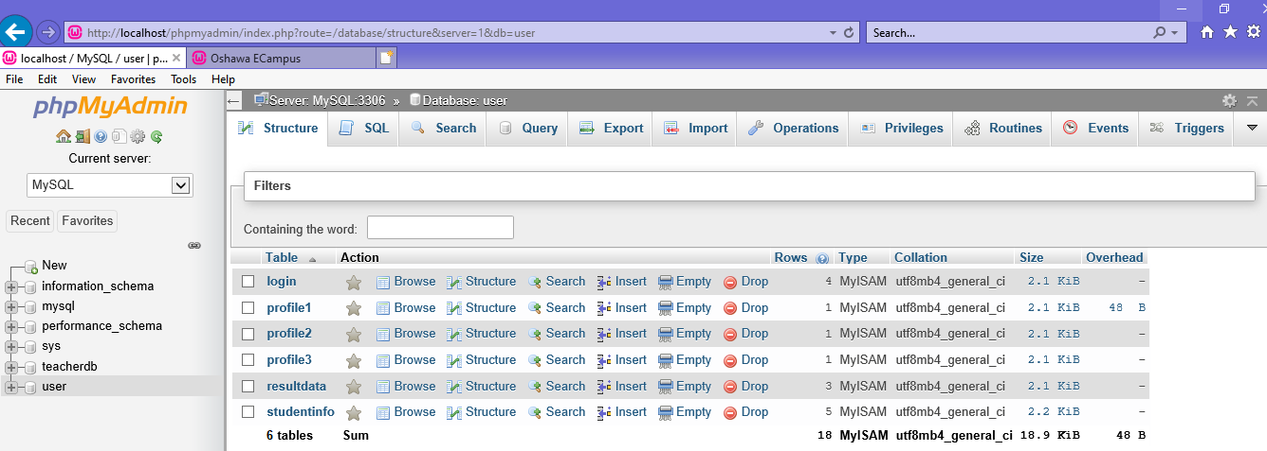

The following tables are:

1. Login
2. Profile1
3. Profile2
4. Profile3
5. ResultData
6. StudentInfo

To Access Login Page, the following code was executed: loginconnection.php

|  |  |
| --- | --- |
| <?php  $host="localhost";  $user="root";  $password="";  $db="user";  $data=mysqli_connect($host, $user, $password, $db);  if($data===false)  {  die("connection_error");  }  if($_SERVER["REQUEST_METHOD"]=="POST")  {  $username=$_POST["username"];  $password=$_POST["password"];  $sql="select * from login where username= '".$username."' AND password='".$password."'";  $result=mysqli_query($data,$sql);  $row=mysqli_fetch_array($result);  if($row["usertype"]=="Ken")  {  $_SESSION["username"]=$username;  header("location:student.php");  }  elseif($row["usertype"]=="Freya")  {  $_SESSION["username"]=$username;  header("location:student2.php");  }  elseif($row["usertype"]=="Anna")  {  $_SESSION["username"]=$username;  header("location:student3.php");  }  elseif($row["usertype"]=="teacher")  {  $_SESSION["username"]=$username;  header("location:teacher.php");  }  else  {  header("location:loginconnection.php");  }  }  ?> | <!DOCTYPE html>  <html>  <head>  <link rel="stylesheet" href="Style1.css">  <title>Oshawa ECampus</title>  </head>  <body>  <section class="header">  <nav>    <div class="nav-links">  <ul>  <li><a href="Main.html">HOME</a></li>  <li><a href="loginconnection.php">LOGIN</a></li>    </ul>  </div>  </nav>  <link rel="stylesheet" href="Style1.css">  <center>    <div class="text-box">  <center>  <h1>Login Form</h1>  <br><br>  <div style="background-color: lightblue; width: 500px;">    <br><br>  <form action="#" method="POST">  <div>    <label>Username</label>  <input class="loginstyle" type="text" name="username" required>  </div>  <br><br>  <div>  <label>Password</label>  <input class="loginstyle" type="password" name="password" required>  </div>  <br><br>  <div>  <input class="btn btn-primary" type="submit" value="Login">  </div>  <br><br>  </center>  </form>  <br><br>  </div>  </center>  </body>  </html> |

The login depends on the usertype if the person is Teacher or a Student.

Use Case Scenarios:

* Teacher Account

|  |  |
| --- | --- |
| System | Website |
| Author(s) | Barsha Shaikh |
| Version | None |
| Name | Login |
| Pre-Condition(s) | The user is registered and has an account on the Oshawa Campus Website. The User is identified as Teacher. |
| Post-Condition(s) | The user is directed to the homepage of the Teacher Dashboard of the Campus. |
| Trigger | The user has clicked on the Login button |
| Normal Flow | 1. User clicks on the Login button 2. User enters the username and the password in the form. 3. User is directed to the homepage specific to the user. |
| Alternate Flow | 1. User can Add Student  2. User can Delete Student Record.  3. User can View Student and the course they are assigned to.  4. User can Add Result for the student. |
| Exceptional Flow(s) | If Login is wrong username or Password the systems takes you back to the login page automatically.  If password is not entered, the system prompts to enter it.  The student record can be entered one at a time.  Upon deleting a student record  The system will prompt the message “Are you sure you want to delete this record?”  The system will prompt the message “Email is not registered”.  The system will prompt the message “Email and Password required”. |
| Related Actor(s) | Primary-Registered User : Teacher |
| Related Use Case(s) | Reset Password, Update Profile, Delete Profile. |

First Page signing in as Teacher:

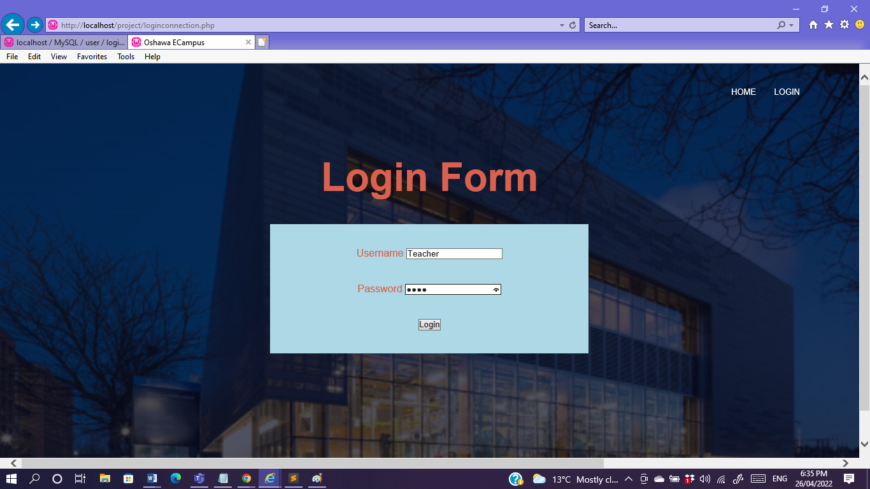

Teacher’s Dashboard:

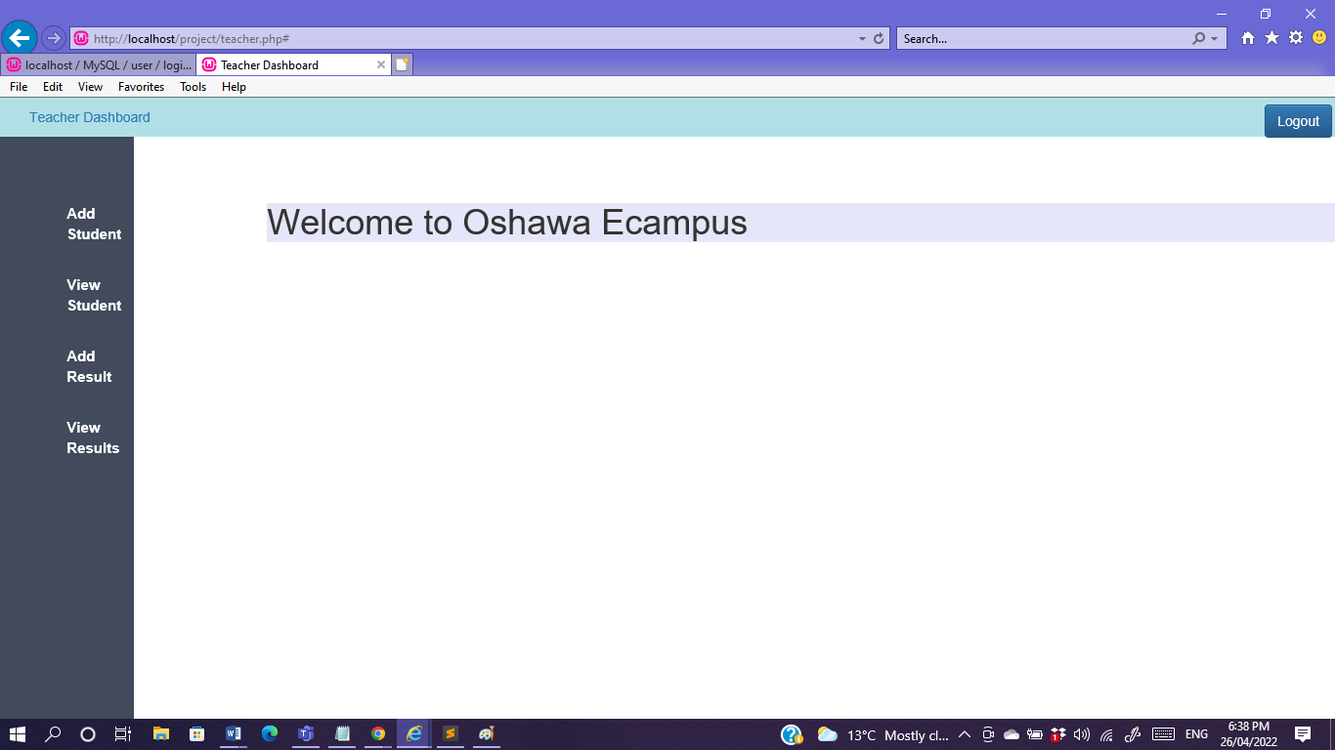

The operations are on the left hand side

First Step to Add Student:

After clicking Add Student the following form appears asking to enter the student details

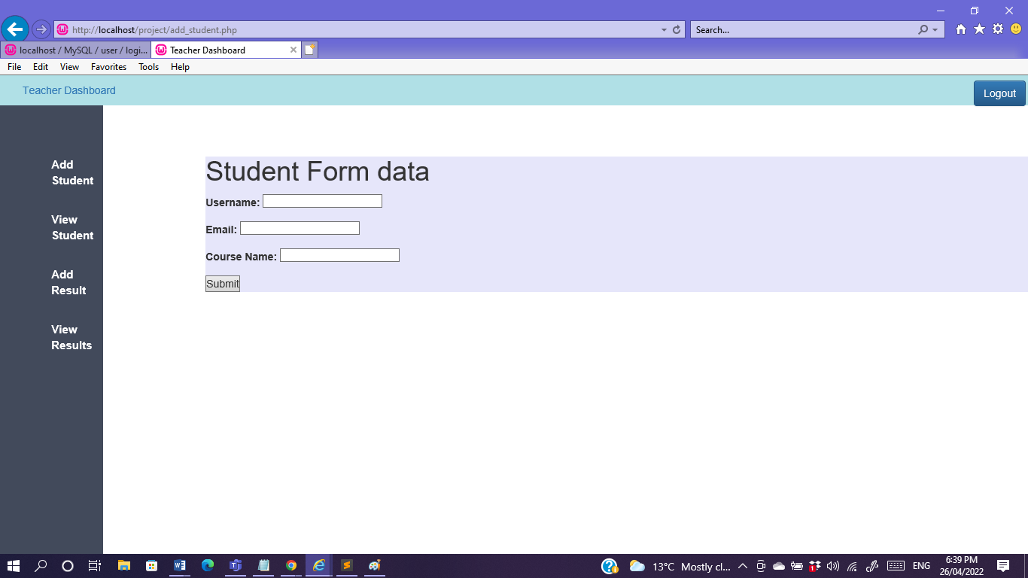

Here student information is entered by teacher:

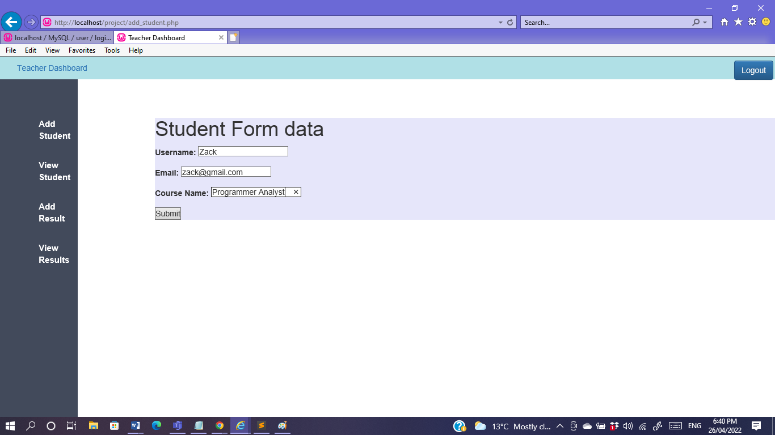

The following information has been added to the database in the table names “studentinfo”

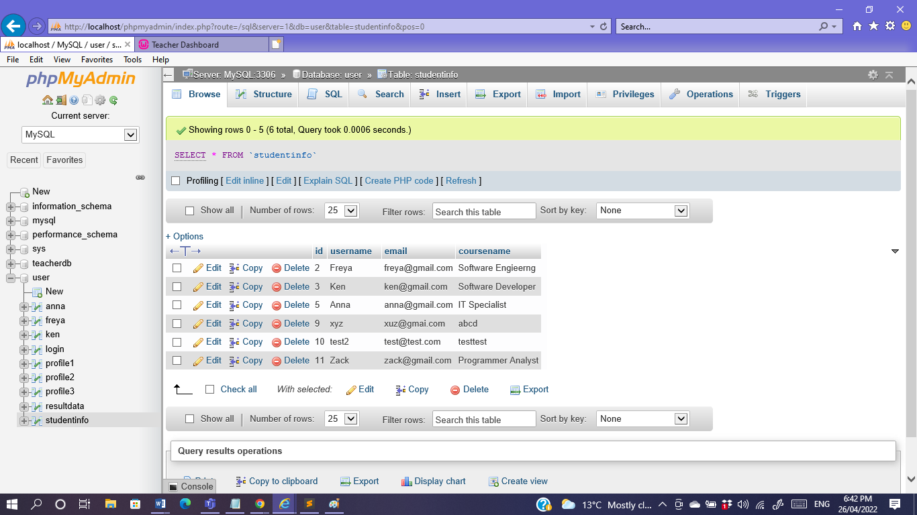

Upon Clicking the View tab on the left of teacher dashboard the following page appears:

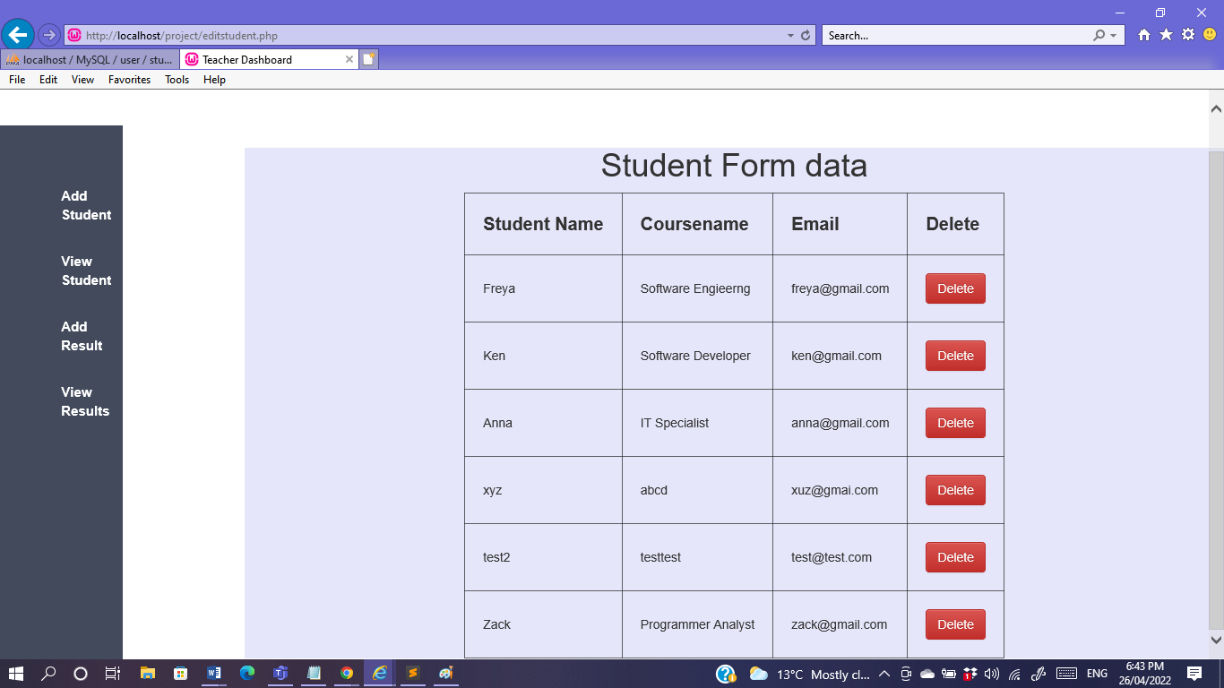

Here all the number of students that were added can be viewed.

If Teacher wants to delete a record of the student for example the following student named Zack was added now the record has to be deleted so by clicking the Delete operations button the following is executed:

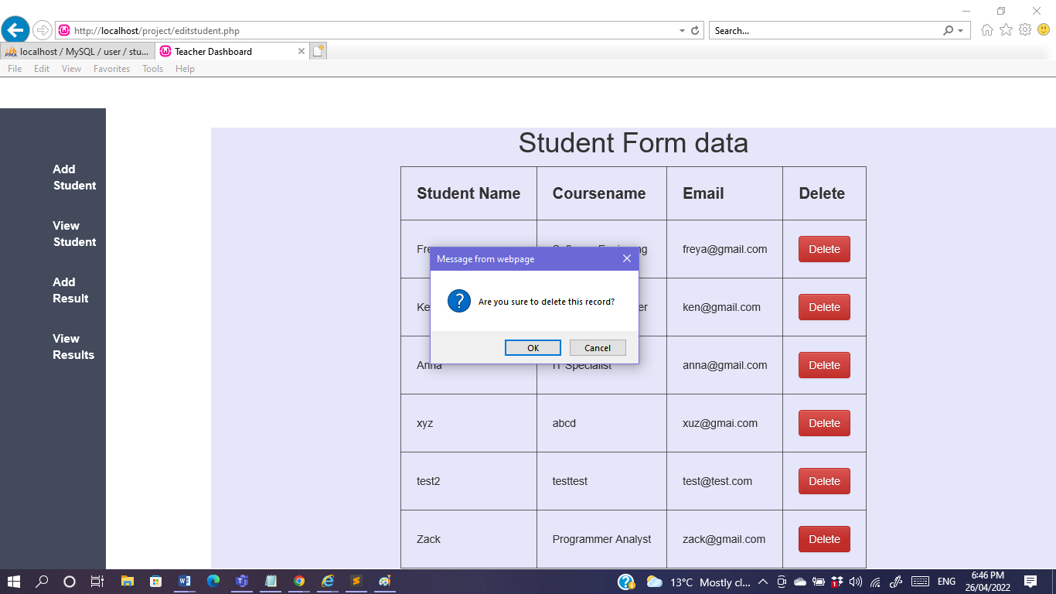

The Delete operation prompts a dialog box asking if teacher is sure to delete this record.

The student names Zack has been successfully deleted.

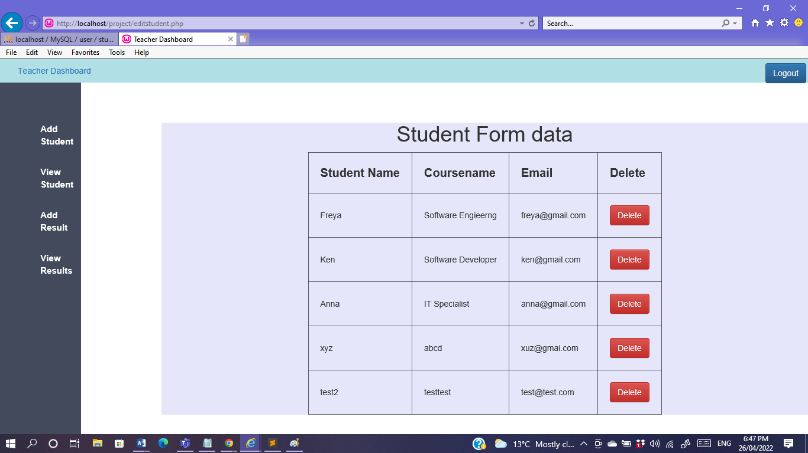

Also on the database the following record for the student Zack is deleted:

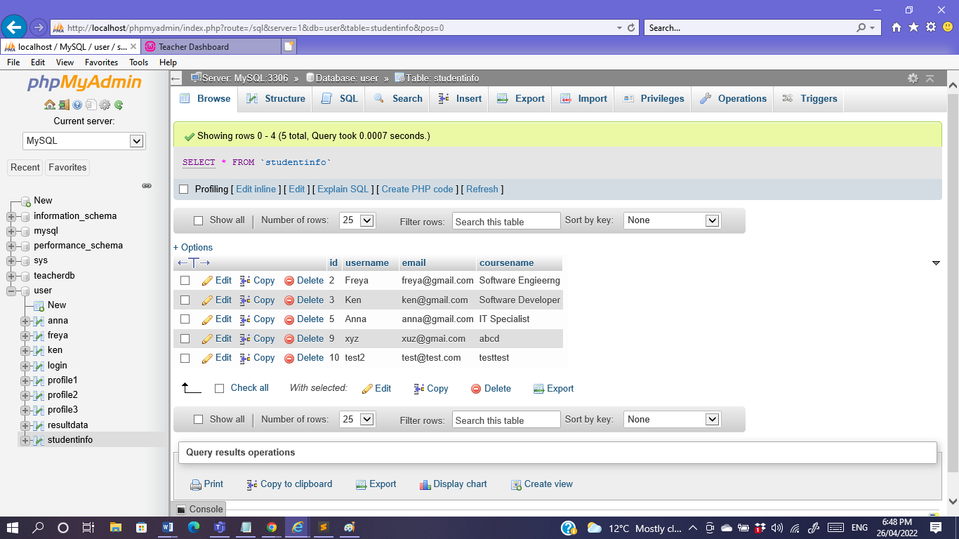

Next Step is to add result for the following student, Teacher clicks on the Add Result on the left of the dashboard, and the following page appears:

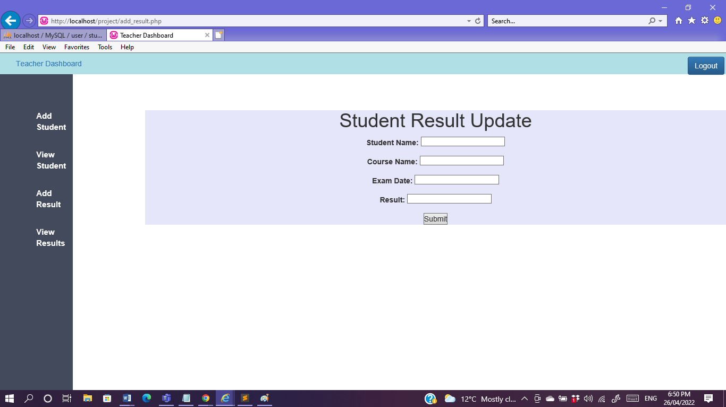

So let’s say, a student Ken recently gave his exam and his project was evaluated and grade is ready.

The teacher adds the following grade to Ken along with the exam date and the course he is doing:

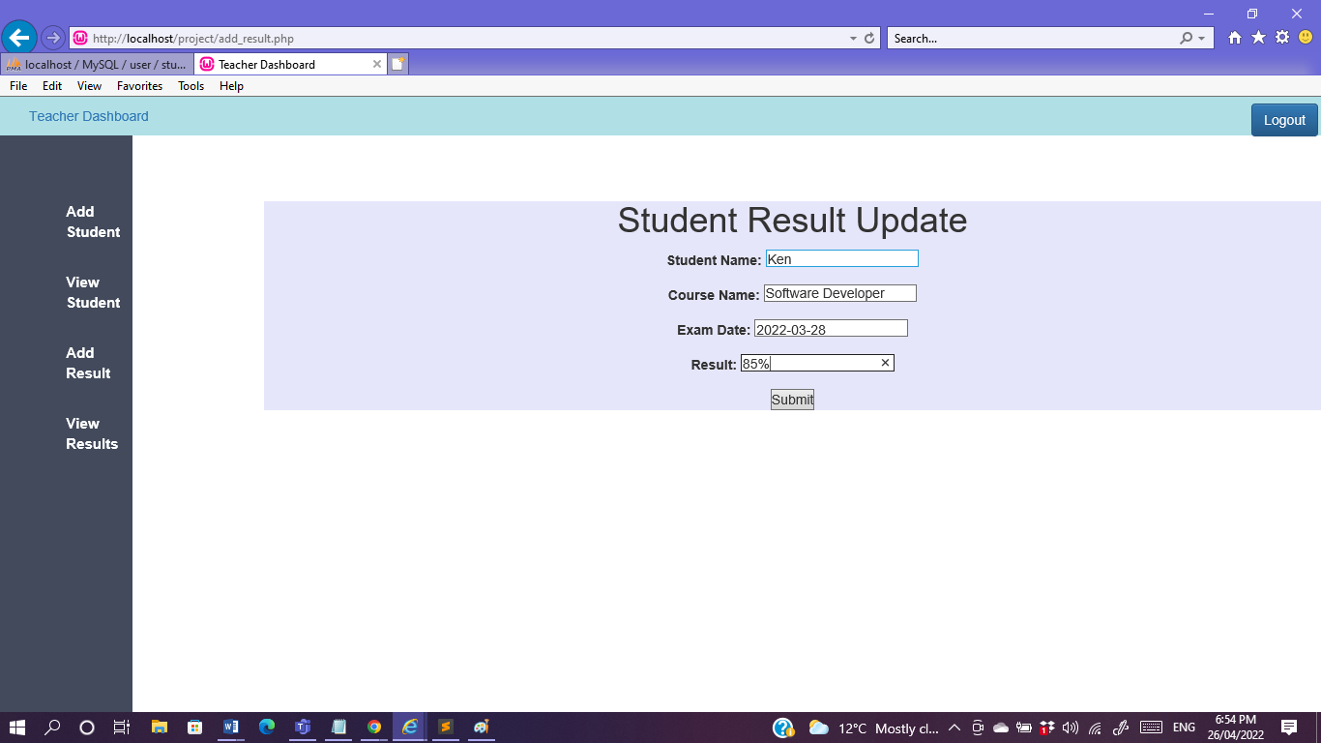

The Following gets added to the Database in the resultdata table:

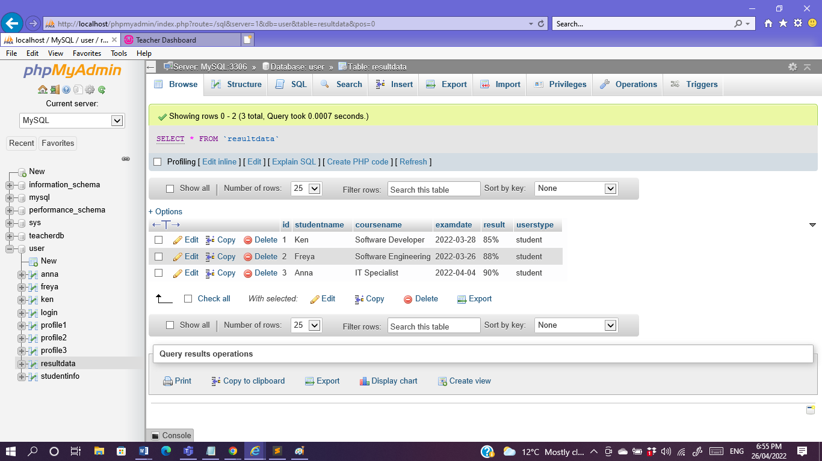

The last operation on the left side of the teacher’s dashboard is the view result of the students whoever the teacher graded so far:

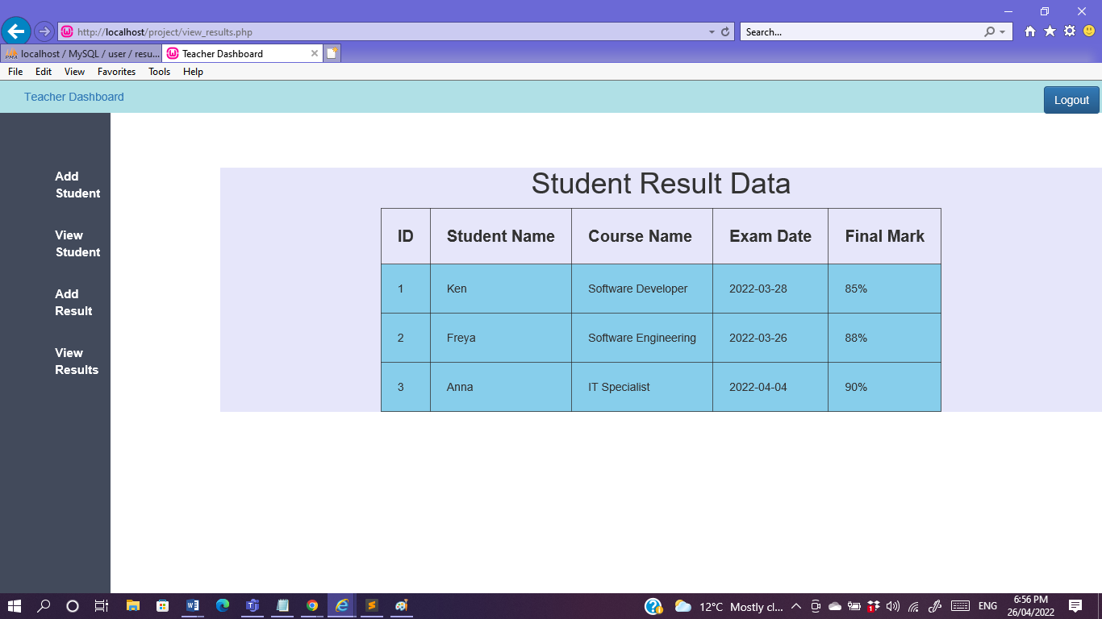

Lastly the user logs out by clicking the logout button which takes them back to the login page:

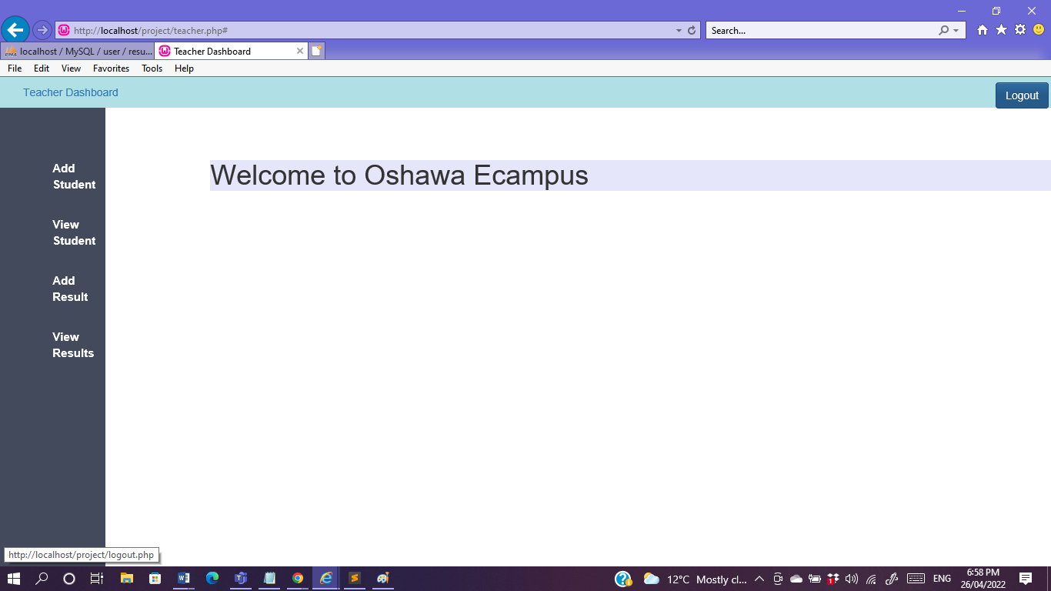

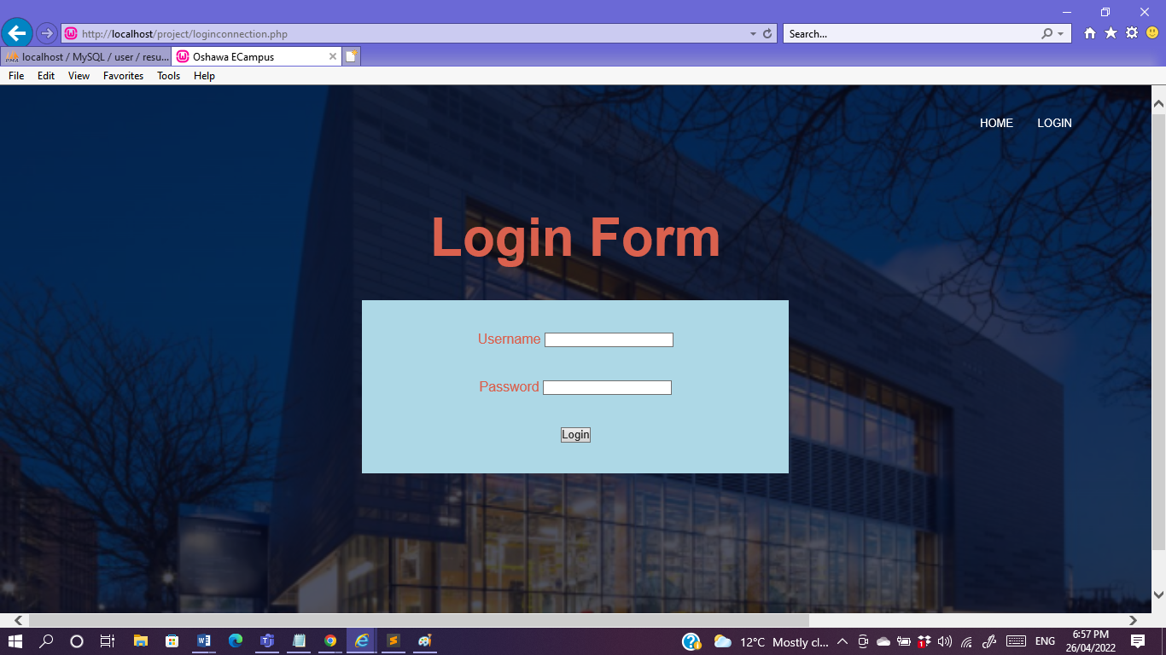

Now the following operation will be logging in as a student.

* Student Profile

|  |  |
| --- | --- |
| System | Website |
| Author(s) | Barsha Shaikh |
| Version | None |
| Name | View Student Profile |
| Pre-Condition(s) | The user is registered and have an account in the website of the Campus. |
| Post-Condition(s) | None |
| Trigger | The user has clicked on the View Profile button. |
| Normal Flow | 1. User clicks on View Profile. 2. User can view personal details like address and Personal details. |
| Alternate Flow | 1. User can click on view courses and can view the course ID and the teachers assigned. 2. User can edit profile settings such as username and email id. 3. Users can view result updated only by the teacher. |
| Exceptional Flow(s) | None |
| Related Actor(s) | Primary-Registered User - Student |
| Related Use Case(s) | View Profile, View Course and View Result. |

For Example as the teacher updated the grades recently for Ken.

Logging in as Ken:

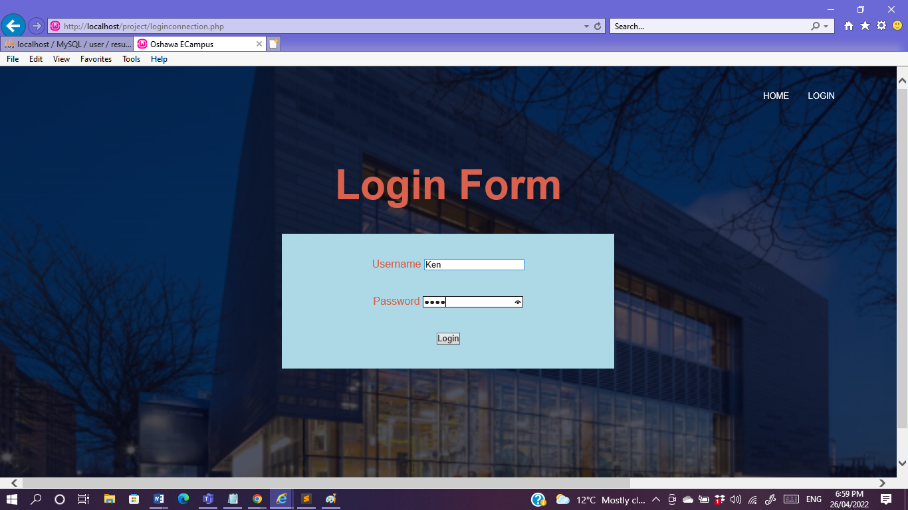

Ken’s first page:

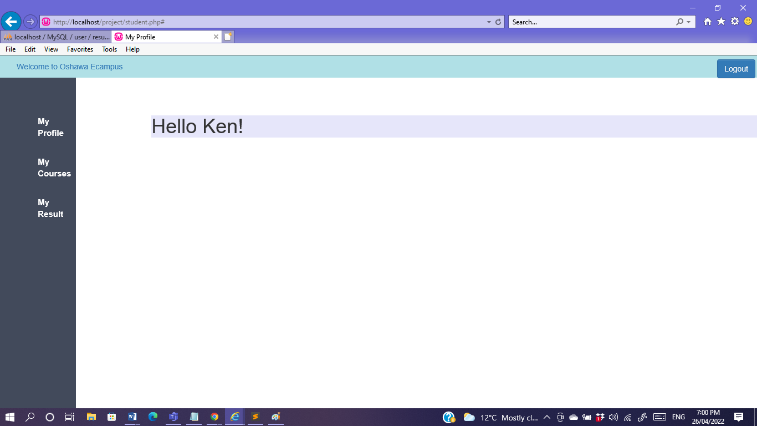

Upon clicking on the profile this is how Ken views his profile:

It shows his Lastname along with address, email and phone no.

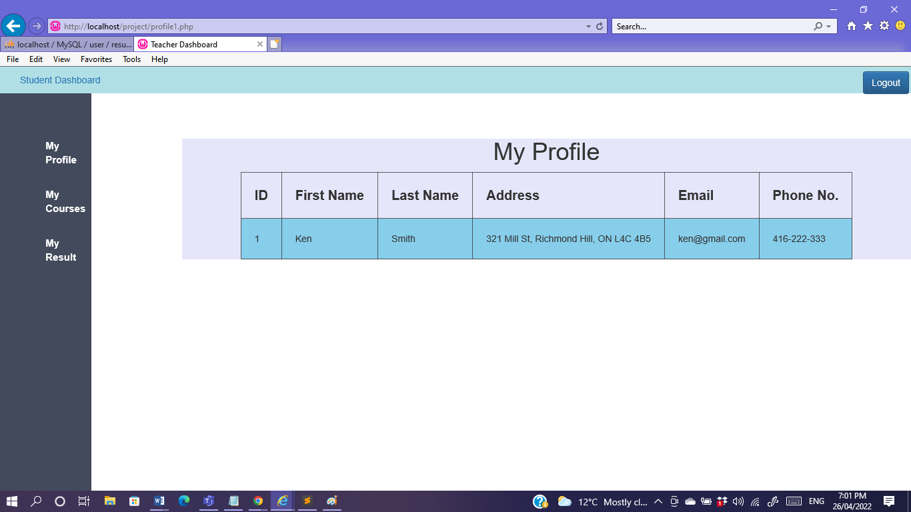

Ken view his courses:

Course ID for the subject he is studying is mentioned along with the assigned professors who is currently teaching.

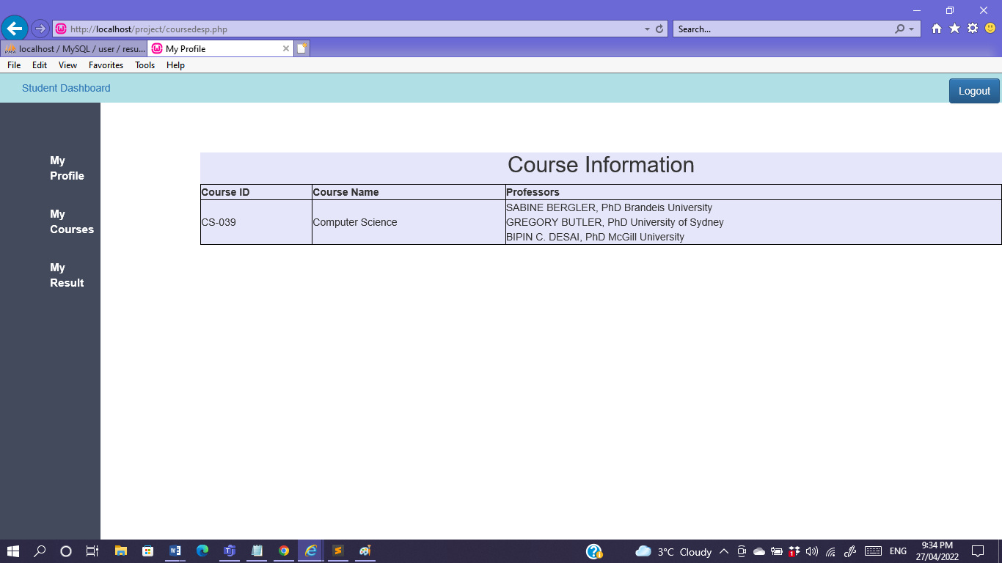

And finally Ken view his result which was recently updated by the teacher:

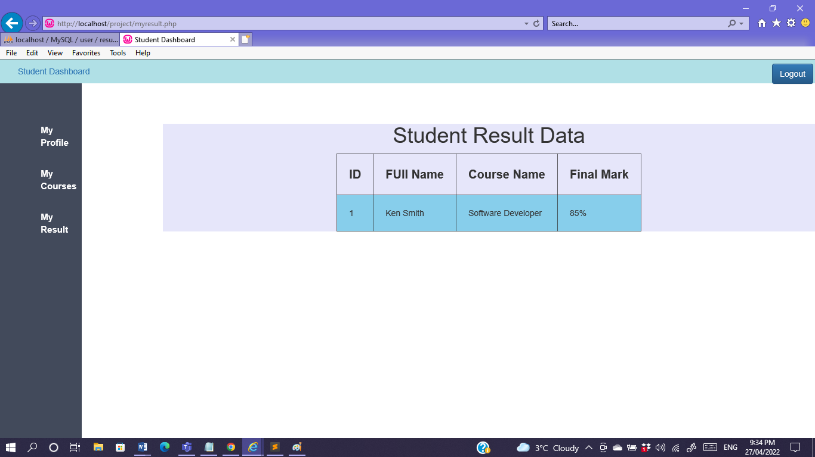

Example of another student Logging in as Freya:

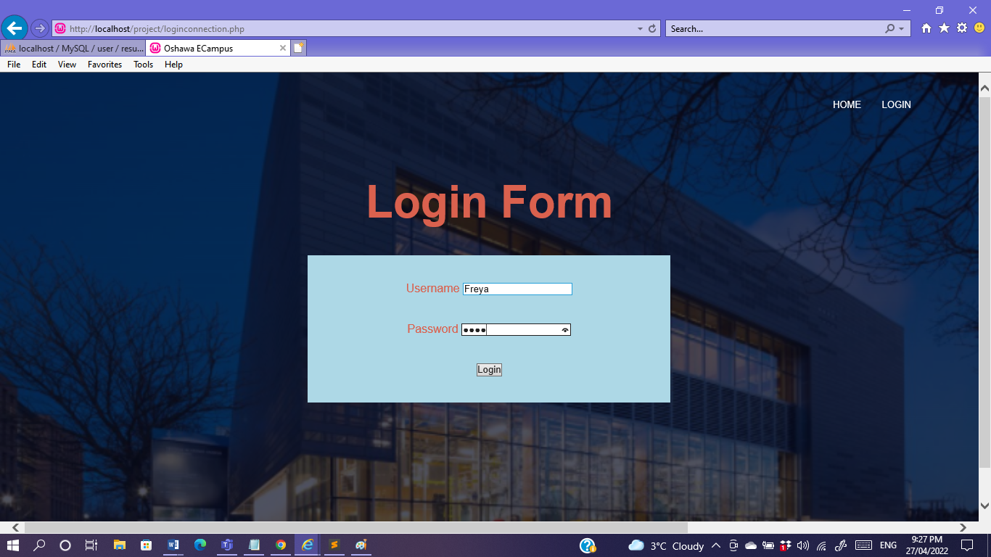

Freya’s first page:

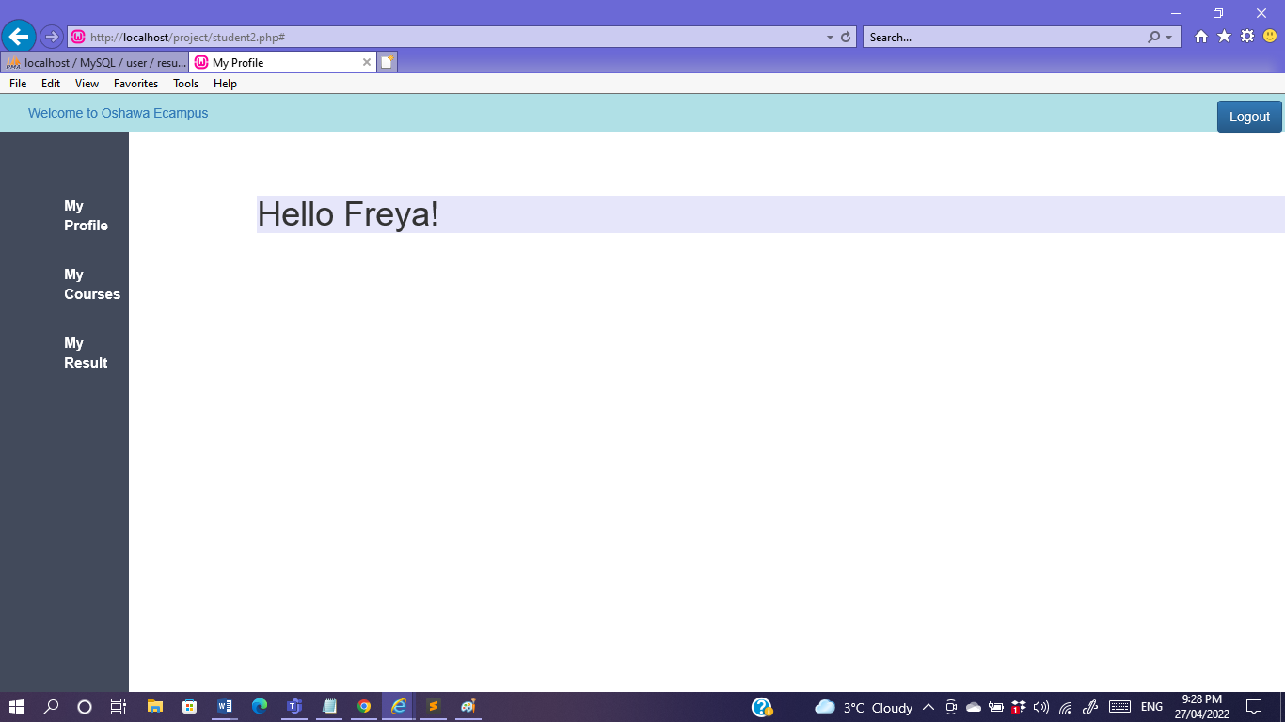

Upon clicking on the profile this is how Freya views her profile:

It shows her Lastname along with address, email and phone no.

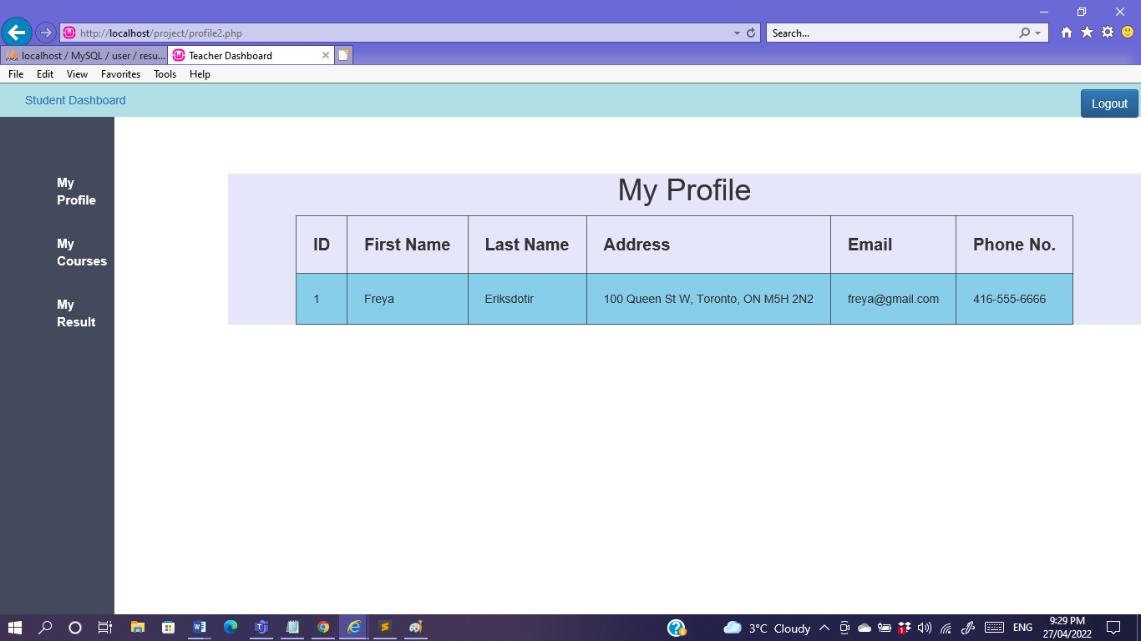

Freya views her courses:

Course ID for the subject she is studying is mentioned along with the assigned professors who is currently teaching.

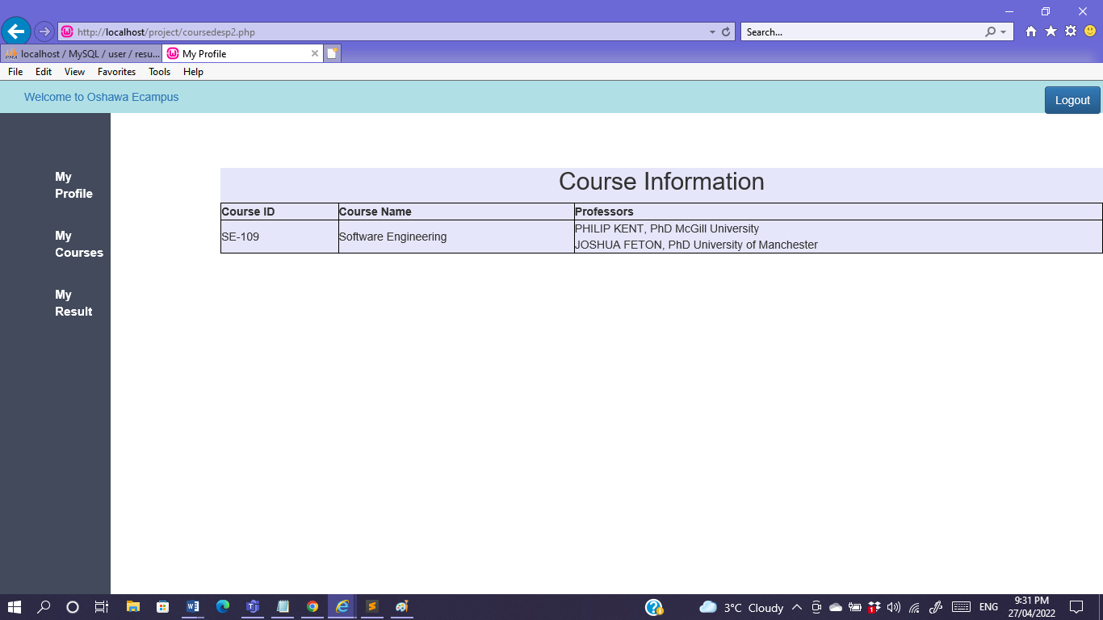

And finally Freya views her result:

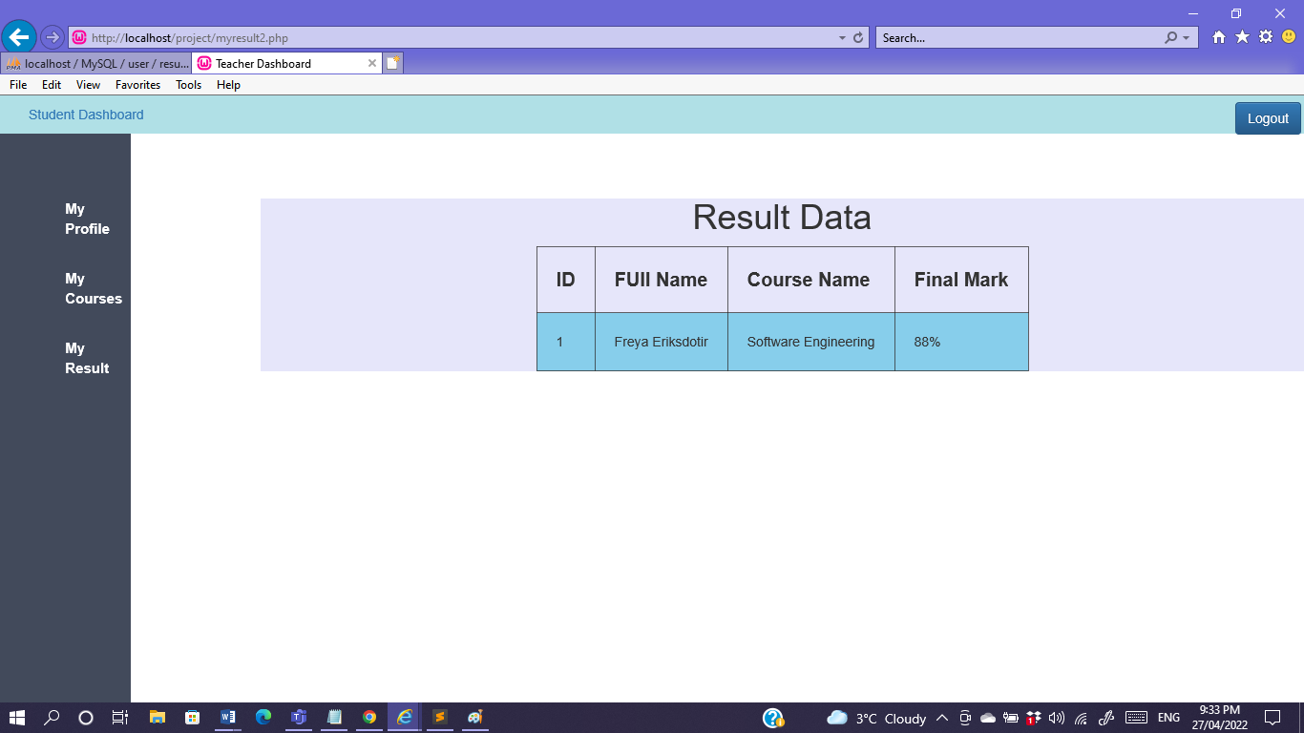

1. Test Cases

|  |  |
| --- | --- |
| **Project Name:** Oshawa Campus | |
| **Test Case** | |
| **Test Case ID:** 001 | **Test Designed by: Barsha Shaikh** |
| **Test Priority (Low/Medium/High):** High | **Test Designed date**: March 20, 2022 |
| **Test Title:** Test the login functionality  Usertype is for Teacher and Student | **Test Executed by: Barsha Shaikh** |
| **Description**: Verify login with valid username and password. | **Test Execution date**: April 4, 2022 |

|  |  |  |  |  |  |  |
| --- | --- | --- | --- | --- | --- | --- |
| **Step** | **Test Steps** | **Test Data** | **Expected Result** | **Actual Result** | **Status (Pass/Fail)** | **Notes** |
| 1 | Navigate to Home page |  | User should click on Login on the top left of the Homepage | Login screen opens | Pass |  |
| 2 | Provide valid username | First name = Teacher | Credentials can be entered | As expected | Pass |  |
| 3 | Provide valid username  (studentname) | First name = Ken | Credentials can be entered | As expected | Pass |  |
| 4 | Provide valid password | Password= 1234 | Credentials can be entered | As expected | Pass |  |
| 5 | Confirm Password | Password= 1234 | Credentials can be entered | As expected | Pass |  |
| 6 | Click on <Login> Button |  | Login Page opens | Login Page opens | Pass |  |

**Post Condition:**  User has signed in successfully.

2.

|  |  |
| --- | --- |
| **Project Name:** Oshawa Campus | |
| **Test Case** | |
| **Test Case ID:** 002 | **Test Designed by: Barsha Shaikh** |
| **Test Priority (Low/Medium/High):** High | **Test Designed date**: April10 , 2022 |
| **Test Title:** Test the Add Student functionality.  Usertype is Teacher | **Test Executed by: Barsha Shaikh** |
| **Description**: Verify add student to be added to the student database. | **Test Execution date**: April 15, 2022 |

|  |  |  |  |  |  |  |
| --- | --- | --- | --- | --- | --- | --- |
| **Step** | **Test Steps** | **Test Data** | **Expected Result** | **Actual Result** | **Status (Pass/Fail)** | **Notes** |
| 1 | After login as Teacher Navigate to the left dashboard |  | User should click on Add Student on the top left of the Dashboard | Add Student Form Data screen opens | Pass |  |
| 2 | Provide valid username, email and coursename of the student | Username = (student name)  Email and Coursename | Credentials can be entered | As expected | Pass |  |
| 3 | Click on <Submit> Button |  | The following is added to the database | Teacher main homepage opens | Pass |  |

**Post Condition:**  User has added student successfully.

3.

|  |  |
| --- | --- |
| **Project Name:** Oshawa Campus | |
| **Test Case** | |
| **Test Case ID:** 003 | **Test Designed by: Barsha Shaikh** |
| **Test Priority (Low/Medium/High):** High | **Test Designed date**: April14 , 2022 |
| **Test Title:** Test the Delete Student Record functionality. Usertype is Teacher | **Test Executed by: Barsha Shaikh** |
| **Description**: Verify Delete button to delete a record from the database | **Test Execution date**: April 16, 2022 |

|  |  |  |  |  |  |  |
| --- | --- | --- | --- | --- | --- | --- |
| **Step** | **Test Steps** | **Test Data** | **Expected Result** | **Actual Result** | **Status (Pass/Fail)** | **Notes** |
| 1 | User should click on View Student on the top left of the Dashboard | Click on delete on the right of the record. | Record gets removed | Record is no more in the list | Pass |  |
| 2 | Click on <Delete> Button |  | The following is deleted on the database | View Student page stays | Pass |  |

**Post Condition:**  User has delete record successfully.

4.

|  |  |
| --- | --- |
| **Project Name:** Oshawa Campus | |
| **Test Case** | |
| **Test Case ID:** 004 | **Test Designed by: Barsha Shaikh** |
| **Test Priority (Low/Medium/High):** High | **Test Designed date**: April15 , 2022 |
| **Test Title:** Test the Add result functionality  usertype is Teacher | **Test Executed by: Barsha Shaikh** |
| **Description**: Verify Add Result for a student | **Test Execution date**: April 18, 2022 |

|  |  |  |  |  |  |  |
| --- | --- | --- | --- | --- | --- | --- |
| **Step** | **Test Steps** | **Test Data** | **Expected Result** | **Actual Result** | **Status (Pass/Fail)** | **Notes** |
| 1 | User should click on Add Result on the top left of the Dashboard | Student Result Update form appears | Add the student name and coursename, the exam date and grades. | The grade is added to the student name | Pass |  |
| 2 | Click on <Submit> Button |  | The following is added in the student record. | Add Result page stays | Pass |  |

**Post Condition:**  User has added grades for the student successfully.

5.

|  |  |
| --- | --- |
| **Project Name:** Oshawa Campus | |
| **Test Case** | |
| **Test Case ID:** 005 | **Test Designed by: Barsha Shaikh** |
| **Test Priority (Low/Medium/High):** High | **Test Designed date**: April20 , 2022 |
| **Test Title:** Logout functionality | **Test Executed by: Barsha Shaikh** |
| **Description**: To logout after user is done accessing their profile. | **Test Execution date**: April 21, 2022 |

|  |  |  |  |  |  |  |
| --- | --- | --- | --- | --- | --- | --- |
| **Step** | **Test Steps** | **Test Data** | **Expected Result** | **Actual Result** | **Status (Pass/Fail)** | **Notes** |
| 1 | User should click on Logout on the top right of the Dashboard | The login page appears | Pass | Login form appears for user to enter their username and password | Pass |  |
| 2 | Click on <Logout> Button | The login page appears | The following will log out | The login page appears | Pass |  |

**Post Condition:**  User has successfully logged out.

6.

|  |  |
| --- | --- |
| **Project Name:** Oshawa Campus | |
| **Test Case** | |
| **Test Case ID:** 006 | **Test Designed by: Barsha Shaikh** |
| **Test Priority (Low/Medium/High):** High | **Test Designed date**: April20 , 2022 |
| **Test Title:** View My profile functionality. usertype is Student | **Test Executed by: Barsha Shaikh** |
| **Description**: To logout after user is done accessing their profile. | **Test Execution date**: April 21, 2022 |

|  |  |  |  |  |  |  |
| --- | --- | --- | --- | --- | --- | --- |
| **Step** | **Test Steps** | **Test Data** | **Expected Result** | **Actual Result** | **Status (Pass/Fail)** | **Notes** |
| 1 | User should click on Logout on the top right of the Dashboard | The login page appears | Pass | Login form appears for user to enter their username and password | Pass |  |
| 2 | Click on <Logout> Button | The login page appears | The following will log out | The login page appears | Pass |  |

**Post Condition:**  User has successfully logged out.

7.

|  |  |
| --- | --- |
| **Project Name:** Oshawa Campus | |
| **Test Case** | |
| **Test Case ID:** 007 | **Test Designed by: Barsha Shaikh** |
| **Test Priority (Low/Medium/High):** High | **Test Designed date**: April20 , 2022 |
| **Test Title:** View My profile functionality. usertype is Student | **Test Executed by: Barsha Shaikh** |
| **Description**: accessing their profile. | **Test Execution date**: April 25, 2022 |

|  |  |  |  |  |  |  |
| --- | --- | --- | --- | --- | --- | --- |
| **Step** | **Test Steps** | **Test Data** | **Expected Result** | **Actual Result** | **Status (Pass/Fail)** | **Notes** |
| 1 | User should click on My Profile on the top left of the Dashboard | The Profile of the student page appears | Pass | Student’s full name, course name, their address and email address appears | Pass |  |
| 2 | Click on <My Profile> | My Profile page appears | The following will gives detail of the student profile | View My profile Page | Pass |  |

**Post Condition:**  User has successfully access their profile.

8.

|  |  |
| --- | --- |
| **Project Name:** Oshawa Campus | |
| **Test Case** | |
| **Test Case ID:** 008 | **Test Designed by: Barsha Shaikh** |
| **Test Priority (Low/Medium/High):** High | **Test Designed date**: April22 , 2022 |
| **Test Title:** View My Course functionality. Usertype is Student | **Test Executed by: Barsha Shaikh** |
| **Description**: accessing their my course. | **Test Execution date**: April 22, 2022 |

|  |  |  |  |  |  |  |
| --- | --- | --- | --- | --- | --- | --- |
| **Step** | **Test Steps** | **Test Data** | **Expected Result** | **Actual Result** | **Status (Pass/Fail)** | **Notes** |
| 1 | User should click on My Course on the top left of the Dashboard | The course information of the student page appears | Pass | Student’s course id,course name, Professors name assigned to that course appears | Pass |  |
| 2 | Click on <My Course> | The My Course page appears | The following gives the course details | View My Course page | Pass |  |

**Post Condition:**  User successfully can view their course details.

9.

|  |  |
| --- | --- |
| **Project Name:** Oshawa Campus | |
| **Test Case** | |
| **Test Case ID:** 009 | **Test Designed by: Barsha Shaikh** |
| **Test Priority (Low/Medium/High):** High | **Test Designed date**: April23 , 2022 |
| **Test Title:** View My Result functionality. Usertype is Student. | **Test Executed by: Barsha Shaikh** |
| **Description**: accessing their grades. | **Test Execution date**: April 25, 2022 |

|  |  |  |  |  |  |  |
| --- | --- | --- | --- | --- | --- | --- |
| **Step** | **Test Steps** | **Test Data** | **Expected Result** | **Actual Result** | **Status (Pass/Fail)** | **Notes** |
| 1 | User should click on My Result on the top left of the Dashboard | The Result information of the student page appears | Pass | Student’s Name, course name and result appears | Pass |  |
| 2 | Click on <My Result> | The My Result page appears | The following gives the student’s result | View My Result page | Pass |  |

**Post Condition:**  User successfully can view their final grade of their course.

10.Errors I have encountered while doing this project:

* PHP Parse error: syntax error, unexpected '{' in teacher.php on line 20
* Fatal error: Uncaught Error: Call to undefined function catch_fatal_error() in C:\wamp64\www\project\add_result.php:15
* Stack trace: #0 {main} thrown in C:\wamp64
* Undefined variable: automobile in C:\wamp64\www\project\add_student.php on line 6
* Parse error: syntax error, unexpected $conn in Command line code on line 1
* Parse error: syntax error, unexpected T_VARIABLE
* PHP Parse error: syntax error, unexpected T_VARIABLE in
* /project/profile.php on line 3
* Warning: mysql_connect() [function.mysql-connect]: Can't connect to MySQL server on 'localhost' (10061) in C:\wamp64\www\\project\loginconnection.php on line 5 Could not connect: Can't connect to MySQL server on 'localhost' (10061)

11.Links Used

We3School, csharpercorner, tutorialrepublc, phpixnap and Youtube.